7
rkets

CONSUMERS, PRODUCERS, AND THE EFFICIENCY OF MARKETS

WHAT’S NEW IN THE SEVENTH EDITION:

There is a new In the News feature on "The Invisible Hand Can Park Your Car."

LEARNING OBJECTIVES:

By the end of this chapter, students should understand:

➢ the link between buyers’ willingness to pay for a good and the demand curve.

➢ how to define and measure consumer surplus.

➢ the link between sellers’ costs of producing a good and the supply curve.

➢ how to define and measure producer surplus.

➢ that the equilibrium of supply and demand maximizes total surplus in a market.

CONTEXT AND PURPOSE:

Chapter 7 is the first chapter in a three-chapter sequence on welfare economics and market efficiency. Chapter 7 employs the supply and demand model to develop consumer surplus and producer surplus as a measure of welfare and market efficiency. These concepts are then utilized in Chapters 8 and 9 to determine the winners and losers from taxation and restrictions on international trade.
The purpose of Chapter 7 is to develop welfare economics—the study of how the allocation of resources affects economic well-being. Chapters 4 through 6 employed supply and demand in a positive framework, which focused on the question, “What is the equilibrium price and quantity in a market?” This chapter now addresses the normative question, “Is the equilibrium price and quantity in a market the best possible solution to the resource allocation problem, or is it simply the price and quantity that balance supply and demand?” Students will discover that under most circumstances the equilibrium price and quantity is also the one that maximizes welfare.

KEY POINTS:

• Consumer surplus equals buyers’ willingness to pay for a good minus the amount they actually pay, and it measures the benefit buyers get from participating in a market. Consumer surplus can be computed by finding the area below the demand curve and above the price.

• Producer surplus equals the amount sellers receive for their goods minus their costs of production, and it measures the benefit sellers get from participating in a market. Producer surplus can be computed by finding the area below the price and above the supply curve.

• An allocation of resources that maximizes the sum of consumer and producer surplus is said to be efficient. Policymakers are often concerned with the efficiency, as well as the equality, of economic outcomes.

• The equilibrium of supply and demand maximizes the sum of consumer and producer surplus. That is, the invisible hand of the marketplace leads buyers and sellers to allocate resources efficiently.

• Markets do not allocate resources efficiently in the presence of market failures such as market power or externalities.

CHAPTER OUTLINE:

I. Definition of welfare economics: the study of how the allocation of resources affects economic well-being.

Students often are confused by the use of the word “welfare.” Remind them that we are talking about social well-being and not public assistance.

II. Consumer Surplus

A. Willingness to Pay

1. Definition of willingness to pay: the maximum amount that a buyer will pay for a good.

2. Example: You are auctioning a mint-condition recording of Elvis Presley’s first album. Four buyers show up. Their willingness to pay is as follows:

Students will understand consumer surplus if you take the time to work through the Elvis Presley example. If you start with this simple example, students will have no trouble understanding how to find consumer surplus on a graph.

Table 1

Buyer | Willingness to Pay
John | $100
Paul | $80
George | $70
Ringo | $50

If the bidding goes to slightly higher than $80, all buyers drop out except for John. Because John is willing to pay more than he has to for the album, he derives some benefit from participating in the market.

3. Definition of consumer surplus: the amount a buyer is willing to pay for a good minus the amount the buyer actually pays for it.

4. Note that if you had more than one copy of the album, the price in the auction would end up being lower (a little over $70 in the case of two albums) and both John and Paul would gain consumer surplus.
Activity 1—Value of a Time Machine

Type: In-class demonstration
Topics: Consumer surplus
Materials needed: None
Time: 10 minutes
Class limitations: Works in any size class

Purpose
Consumer surplus can be a hard concept for students because it is based on avoided expense rather than on money that is actually exchanged. This example puts a specific dollar value on consumer surplus.

Instructions
Tell the class, “A new technology has been developed that allows individuals to travel backward or forward in time. We want to identify the value this time machine provides to consumers. Let’s assume the four consumers who most desire this product are in this class.”

Choose four student names and use them in the following example:

“Scott is the consumer who most values this product. He wants to go back to the time of the dinosaurs. He is willing to pay $3,000.”
“Carol is the consumer with the next highest willingness to pay. She would like to see 200 years in the future. She’d pay $2,500.”
“Steve is the next highest bidder. He’d like to relive this entire semester. He’ll pay up to $800.”
“Jeanne is our fourth consumer. She’d pay $200 to move the clock forward to the end of this class period.”

On the board write:
Scott $3,000
Carol $2,500
Steve $800
Jeanne $200

“This represents the demand curve for the time machine. Consumer surplus is the difference between what consumers are willing to pay and the amount they actually have to pay. The market price will determine who uses the time machine and how much surplus they keep.”

“If the price of a time machine ride was $500, three rides would be sold—one to Scott, one to Carol, and one to Steve. Jeanne is not willing to pay $500, so she wouldn’t time travel.”

“We can calculate the consumer surplus of three time trips. Scott would pay $3,000 but only pays $500, leaving $2,500 of net benefits.” (Put these numbers on the board.) “Carol has net benefits of $2,000. Steve has $300 in net benefits. Adding up these net savings gives $4,800 in consumer surplus.”

Points for Discussion
The consumer surplus depends on a good’s selling price and the number of consumers who are willing to purchase the good at that price. The lower the price, the greater the consumer surplus.

B. Using the Demand Curve to Measure Consumer Surplus

1. We can use the information on willingness to pay to derive a demand curve for the rare Elvis Presley album.
Figure 1
Price of Album

100
Price | Buyers | Quantity Demanded  80
More than $100 | None | 0  70
$80 to $100 | John | 1
$70 to $80 | John, Paul | 2  50
$50 to $70 | John, Paul, George | 3  Demand
$50 or less | John, Paul, George, Ringo | 4
Quantity
1
2
3
4
0

2. At any given quantity, the price given by the demand curve reflects the willingness to pay of the marginal buyer. Because the demand curve shows the buyers’ willingness to pay, we can use the demand curve to measure consumer surplus.
Figure 2

3. Consumer surplus can be measured as the area below the demand curve and above the price.

C. How a Lower Price Raises Consumer Surplus
Figure 3

1. As price falls, consumer surplus increases for two reasons.

a. Those already buying the product will receive additional consumer surplus because they are paying less for the product than before (area A on the graph).

b. Because the price is now lower, some new buyers will enter the market and receive consumer surplus on these additional units of output purchased (area B on the graph).

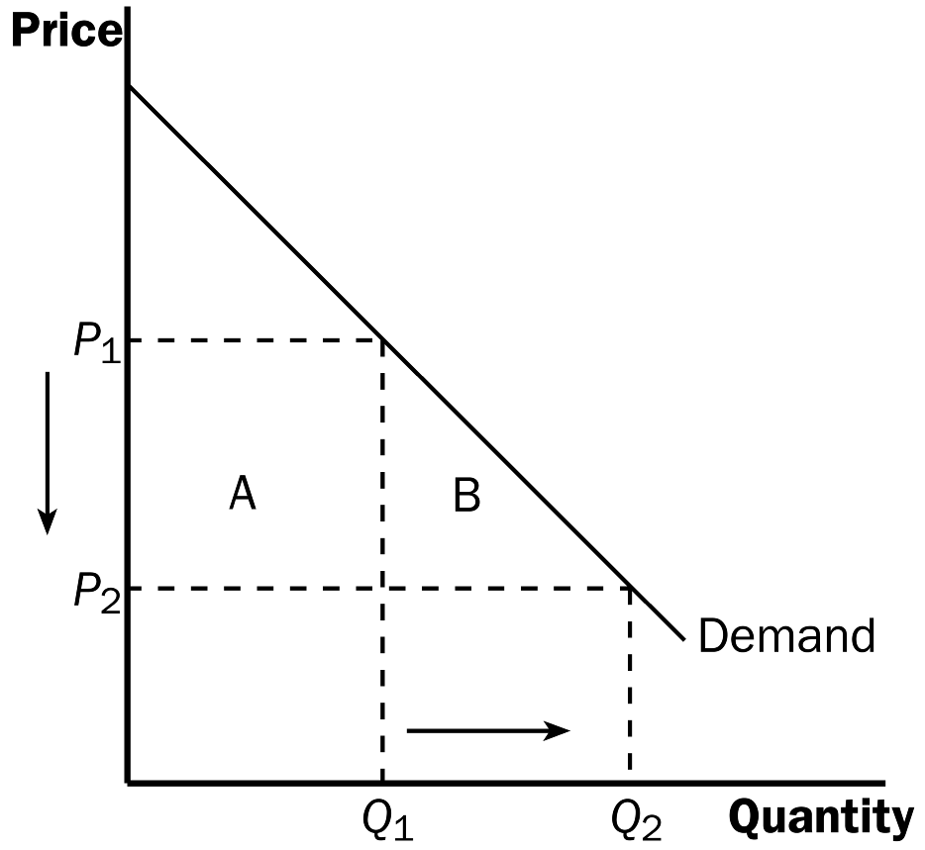

D. What Does Consumer Surplus Measure?
It is important to stress that consumer surplus is measured in monetary terms. Consumer surplus gives us a way to place a monetary cost on inefficient market outcomes (due to government involvement or market failure).

1. Remember that consumer surplus is the difference between the amount that buyers are willing to pay for a good and the price that they actually pay.

2. Thus, it measures the benefit that consumers receive from the good as the buyers themselves perceive it.

ALTERNATIVE CLASSROOM EXAMPLE:
Review the material on price ceilings from Chapter 6. Redraw the market for two-bedroom apartments in your town. Draw in a price ceiling below the equilibrium price.

Then go through:
▪ consumer surplus before the price ceiling is put into place.
▪ consumer surplus after the price ceiling is put into place.

III. Producer Surplus

A. Cost and the Willingness to Sell

1. Definition of cost: the value of everything a seller must give up to produce a good.

You will need to take some time to explain the relationship between the producers’ willingness to sell and the cost of producing the good. The relationship between cost and the supply curve is not as apparent as the relationship between the demand curve and willingness to pay.

2. Example: You want to hire someone to paint your house. You accept bids for the work from four sellers. Each painter is willing to work if the price you will pay exceeds her opportunity cost. (Note that this opportunity cost thus represents willingness to sell.) The costs are:
Table 2
Seller | Cost
Mary | $900
Frida | $800
Georgia | $600
Grandma | $500

3. Bidding will stop when the price gets to be slightly below $600. All sellers will drop out except for Grandma. Because Grandma receives more than she would require to paint the house, she derives some benefit from producing in the market.

4. Definition of producer surplus: the amount a seller is paid for a good minus the seller’s cost of providing it.

5. Note that if you had more than one house to paint, the price in the auction would end up being higher (a little under $800 in the case of two houses) and both Grandma and Georgia would gain producer surplus.

B. Using the Supply Curve to Measure Producer Surplus

1. We can use the information on cost (willingness to sell) to derive a supply curve for house painting services.
Price of House Painting
Figure 4
Supply

900
Price | Sellers | Quantity Supplied  800
$900 or more | Mary, Frida, Georgia, Grandma | 4  500  600
$800 to $900 | Frida, Georgia, Grandma | 3
$600 to $800 | Georgia, Grandma | 2
$500 to $600 | Grandma | 1
less than $500 | None | 0  1  2  3  4  0
Quantity

2. At any given quantity, the price given by the supply curve represents the cost of the marginal seller. Because the supply curve shows the sellers’ cost (willingness to sell), we can use the supply curve to measure producer surplus.

3. Producer surplus can be measured as the area above the supply curve and below the price.
Figure 5
C. How a Higher Price Raises Producer Surplus
Figure 6

1. As price rises, producer surplus increases for two reasons.

a. Those already selling the product will receive additional producer surplus because they are receiving more for the product than before (area C on the graph).

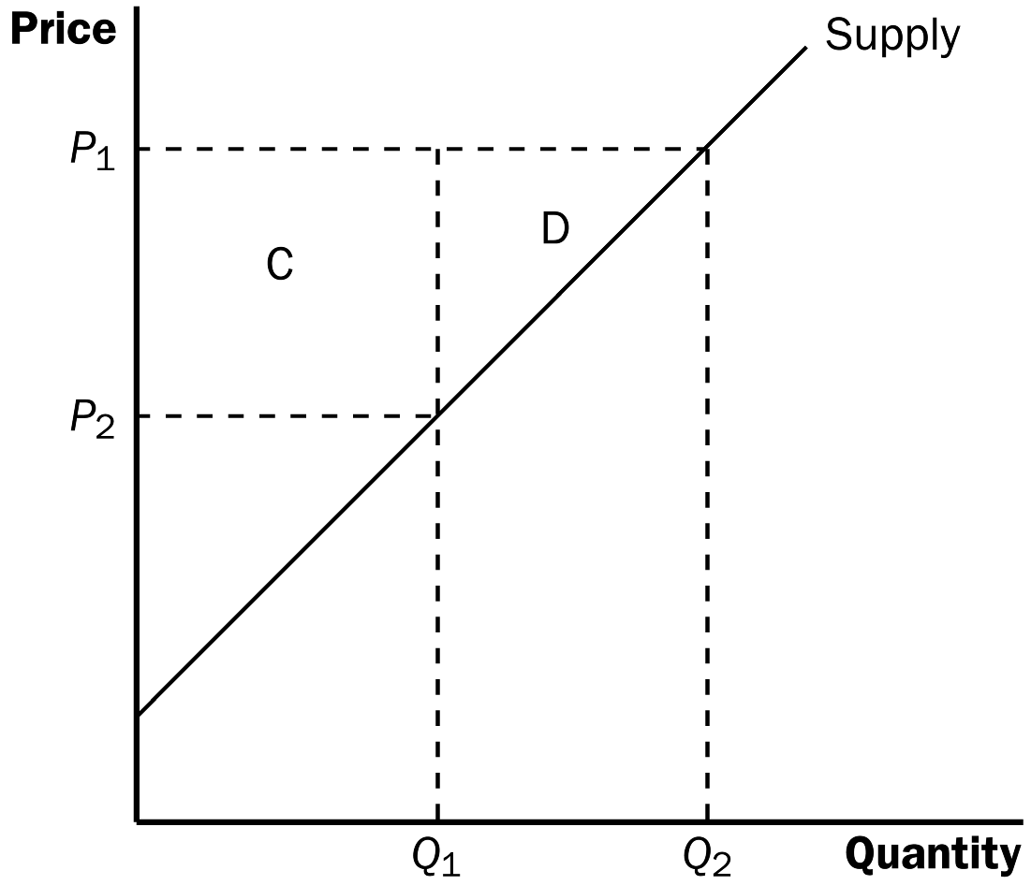

b. Because the price is now higher, some new sellers will enter the market and receive producer surplus on these additional units of output sold (area D on the graph).

D. Producer surplus is used to measure the economic well-being of producers, much like consumer surplus is used to measure the economic well-being of consumers.
ALTERNATIVE CLASSROOM EXAMPLE:
Review the material on price floors from Chapter 6. Redraw the market for an agricultural product such as corn. Draw in a price support above the equilibrium price.

Then go through:
▪ producer surplus before the price support is put in place.
▪ producer surplus after the price support is put in place.

Make sure that you discuss the cost of the price support to taxpayers.

IV. Market Efficiency

A. The Benevolent Social Planner

1. The economic well-being of everyone in society can be measured by total surplus, which is the sum of consumer surplus and producer surplus:

Total Surplus = Consumer Surplus + Producer Surplus

Total Surplus = (Value to Buyers – Amount Paid by Buyers) +
(Amount Received by Sellers – Cost to Sellers)

Because the Amount Paid by Buyers = Amount Received by
Sellers:

2. Definition of efficiency: the property of a resource allocation of maximizing the total surplus received by all members of society.

3. Definition of equality: the property of distributing economic prosperity uniformly the members of society.
Now might be a good time to point out that many government policies involve a trade-off between efficiency and equity. When you evaluate government policies, like price ceilings or floors, you can explain them in terms of equity and efficiency.

B. Evaluating the Market Equilibrium

Figure 7

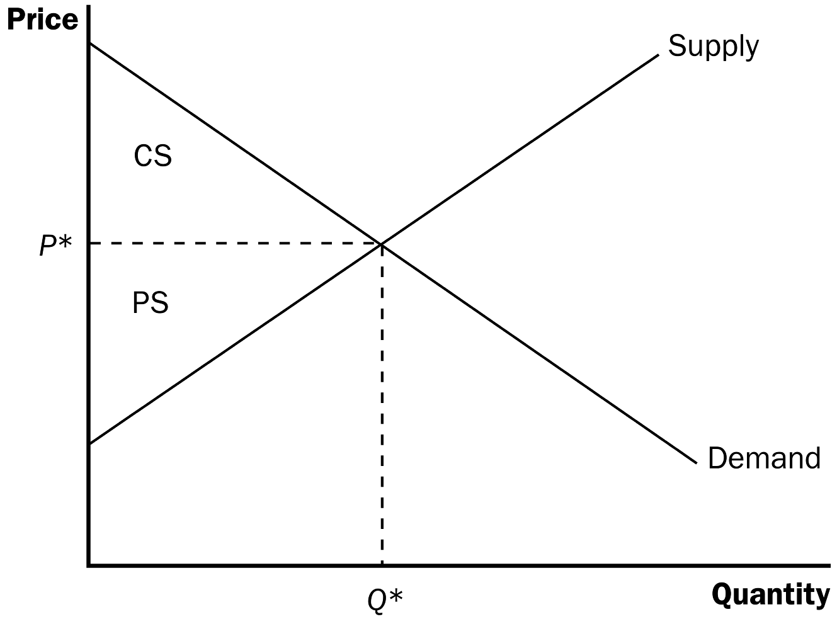

1. At the market equilibrium price:

a. Buyers who value the product more than the equilibrium price will purchase the product; those who do not, will not purchase the product. In other words, the free market allocates the supply of a good to the buyers who value it most highly, as measured by their willingness to pay.

b. Sellers whose costs are lower than the equilibrium price will produce the product; those whose costs are higher, will not produce the product. In other words, the free market allocates the demand for goods to the sellers who can produce it at the lowest cost.

2. Total surplus is maximized at the market equilibrium.

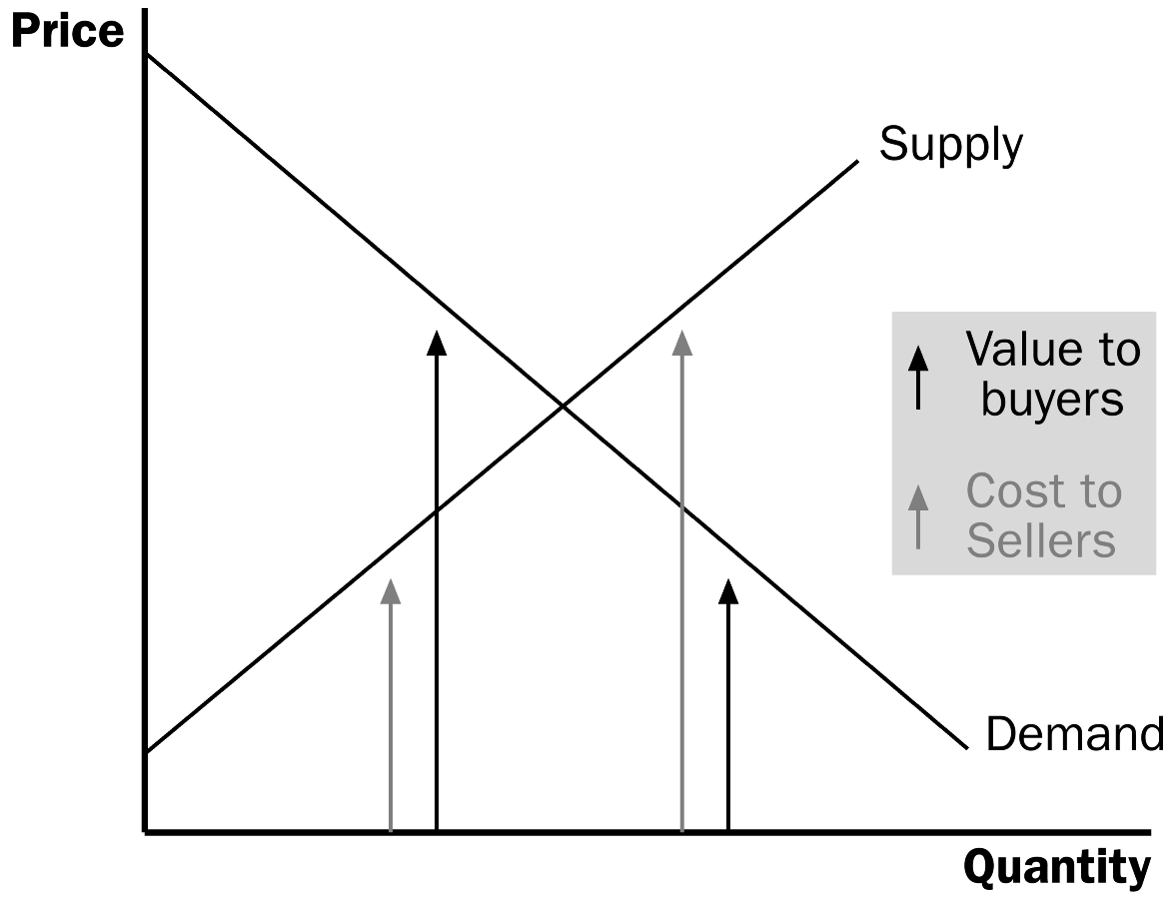
Figure 8

a. At any quantity of output smaller than the equilibrium quantity, the value of the product to the marginal buyer is greater than the cost to the marginal seller so total surplus would rise if output increases.

b. At any quantity of output greater than the equilibrium quantity, the value of the product to the marginal buyer is less than the cost to the marginal seller so total surplus would rise if output decreases.

3. Note that this is one of the reasons that economists believe Principle #6: Markets are usually a good way to organize economic activity.

It would be a good idea to remind students that there are circumstances when the market process does not lead to the most efficient outcome. Examples include situations such as when a firm (or buyer) has market power over price or when there are externalities present. These situations will be discussed in later chapters.

C. In the News: The Invisible Hand Can Park Your Car

1. Parking spots with meters that have variable rates depending on demand and supply can result in a more efficient allocation of this scarce resource.

2. This article from The New York Times describes an experiment with parking meter rates in San Francisco..

D. Case Study: Should There Be a Market in Organs?

1. As a matter of public policy, people are not allowed to sell their organs.

a. In essence, this means that there is a price ceiling on organs of $0.

b. This has led to a shortage of organs.

2. The creation of a market for organs would lead to a more efficient allocation of resources, but critics worry about the equity of a market system for organs.

V. Market Efficiency and Market Failure

A. To conclude that markets are efficient, we made several assumptions about how markets worked.

1. Perfectly competitive markets.

2. No externalities.

B. When these assumptions do not hold, the market equilibrium may not be efficient.

C. When markets fail, public policy can potentially remedy the situation.

SOLUTIONS TO TEXT PROBLEMS:

Quick Quizzes

1. Figure 1 shows the demand curve for turkey. The price of turkey is P₁ and the consumer surplus that results from that price is denoted CS. Consumer surplus is the amount a buyer is willing to pay for a good minus the amount the buyer actually pays for it. It measures the benefit to buyers of participating in a market.

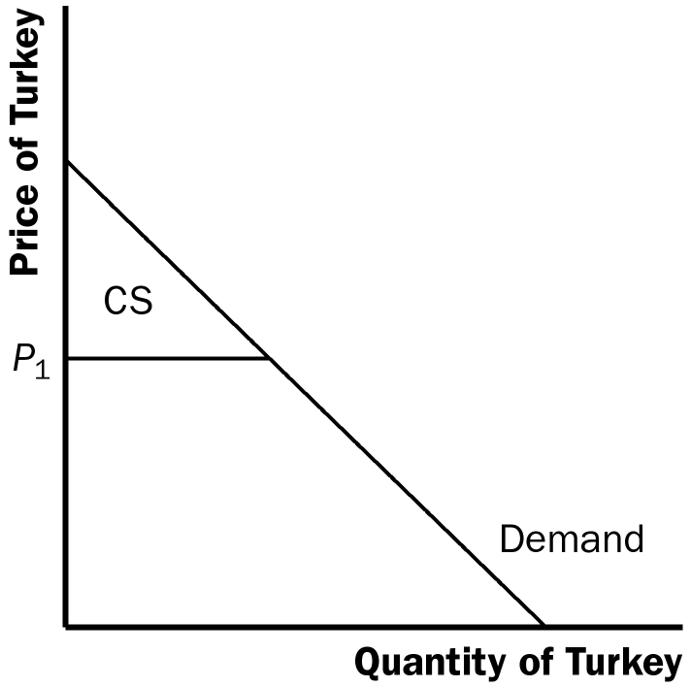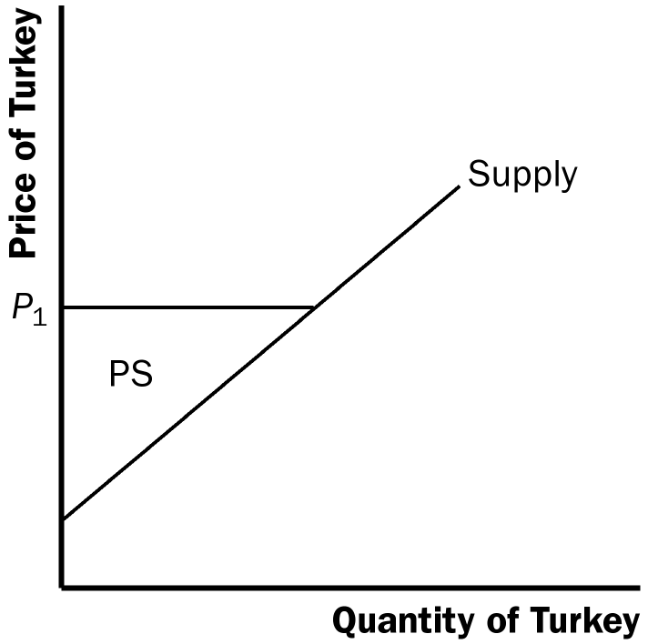

Figure 1 Figure 2

2. Figure 2 shows the supply curve for turkey. The price of turkey is P₁ and the producer surplus that results from that price is denoted PS. Producer surplus is the amount sellers are paid for a good minus the sellers’ cost of providing it (measured by the supply curve). It measures the benefit to sellers of participating in a market.

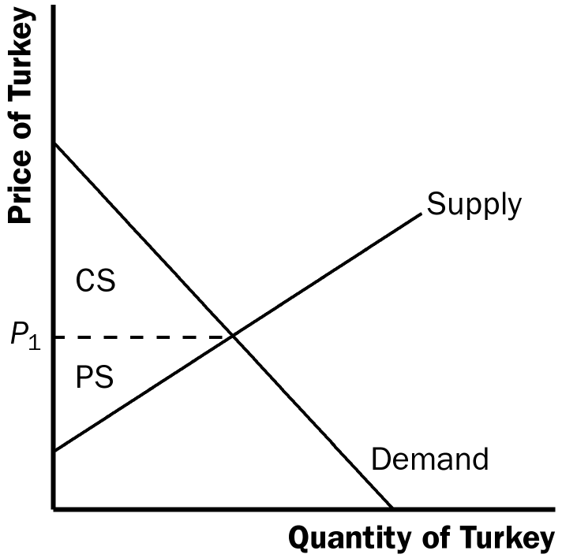

Figure 3

3. Figure 3 shows the supply and demand for turkey. The price of turkey is P₁, consumer surplus is CS, and producer surplus is PS. Producing more turkeys than the equilibrium quantity would lower total surplus because the value to the marginal buyer would be lower than the cost to the marginal seller on those additional units.

Questions for Review

1. The price a buyer is willing to pay, consumer surplus, and the demand curve are all closely related. The height of the demand curve represents the willingness to pay of the buyers. Consumer surplus is the area below the demand curve and above the price, which equals the price that each buyer is willing to pay minus the price actually paid.

2. Sellers' costs, producer surplus, and the supply curve are all closely related. The height of the supply curve represents the costs of the sellers. Producer surplus is the area below the price and above the supply curve, which equals the price received minus each seller's costs of producing the good.

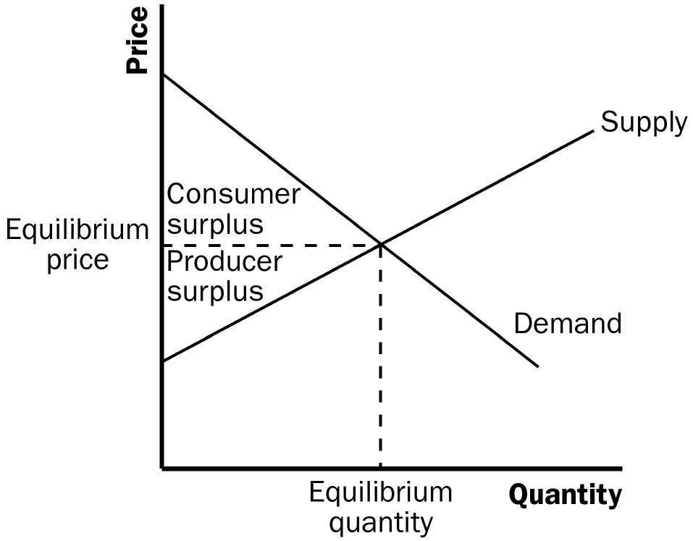

Figure 4

3. Figure 4 shows producer and consumer surplus in a supply-and-demand diagram.

4. An allocation of resources is efficient if it maximizes total surplus, the sum of consumer surplus and producer surplus. But efficiency may not be the only goal of economic policymakers; they may also be concerned about equality⎯the uniform distribution of economic prosperity among the members of society.

5. Two types of market failure are market power and externalities. Market power may cause market outcomes to be inefficient because firms may cause price and quantity to differ from the levels they would be under perfect competition, which keeps total surplus from being maximized. Externalities are side effects that are not taken into account by buyers and sellers. As a result, the free market does not maximize total surplus.

Quick Check Multiple Choice

1. a

2. a

3. b

4. c

5. b

6. c

Problems and Applications

1. a. Consumer surplus is equal to willingness to pay minus the price paid. Therefore, Melissa’s willingness to pay must be $200 ($120 + $80).

b. Her consumer surplus at a price of $90 would be $200 − $90 = $110.

c. If the price of an iPhone was $250, Melissa would not have purchased one because the price is greater than her willingness to pay. Therefore, she would receive no consumer surplus.

2. If an early freeze in California sours the lemon crop, the supply curve for lemons shifts to the left, as shown in Figure 5. The result is a rise in the price of lemons and a decline in consumer surplus from A + B + C to just A. So consumer surplus declines by the amount B + C.

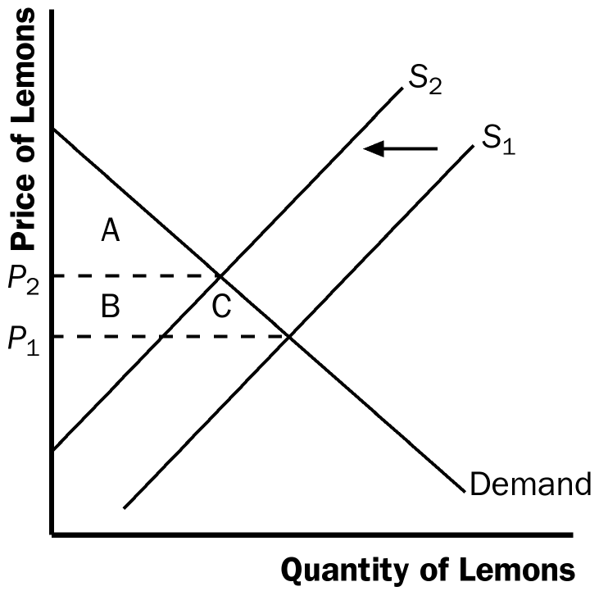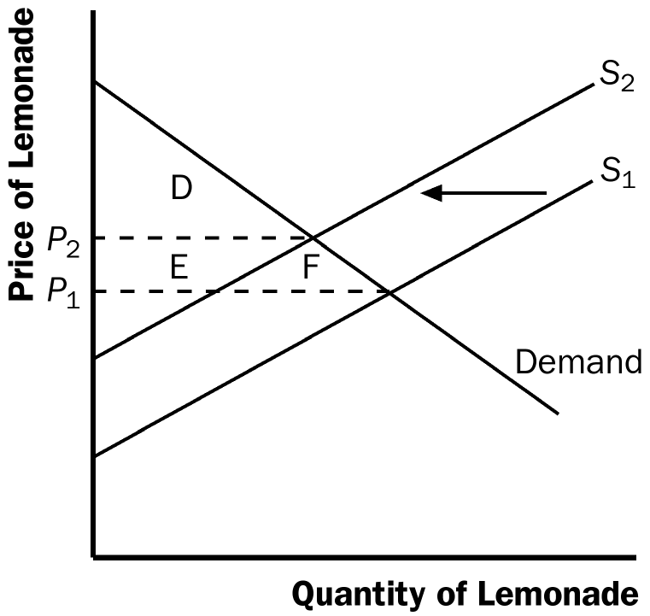

Figure 5 Figure 6

In the market for lemonade, the higher cost of lemons reduces the supply of lemonade, as shown in Figure 6. The result is an increase in the price of lemonade and a decline in consumer surplus from D + E + F to just D, a loss of E + F. Note that an event that affects consumer surplus in one market often has effects on consumer surplus in other markets.

3. A rise in the demand for French bread leads to an increase in producer surplus in the market for French bread, as shown in Figure 7. The shift of the demand curve leads to an increased price, which increases producer surplus from area A to area A + B + C.

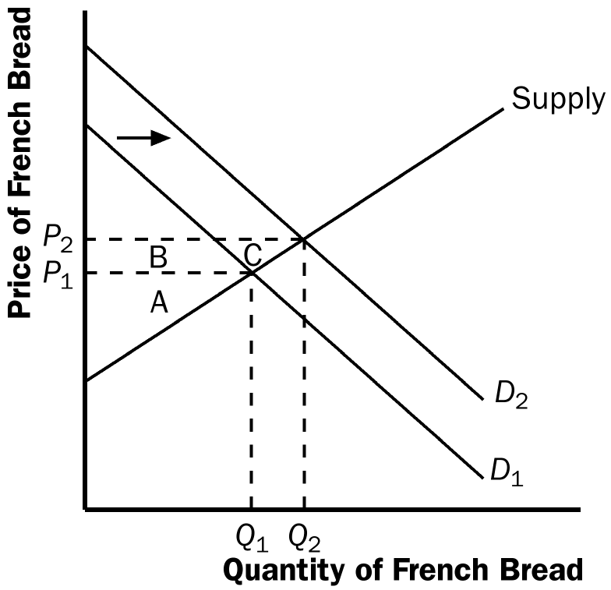

Figure 7

The increased quantity of French bread being sold increases the demand for flour, as shown in Figure 8. As a result, the price of flour rises, increasing producer surplus from area D to D + E + F. Note that an event that affects producer surplus in one market leads to effects on producer surplus in related markets.

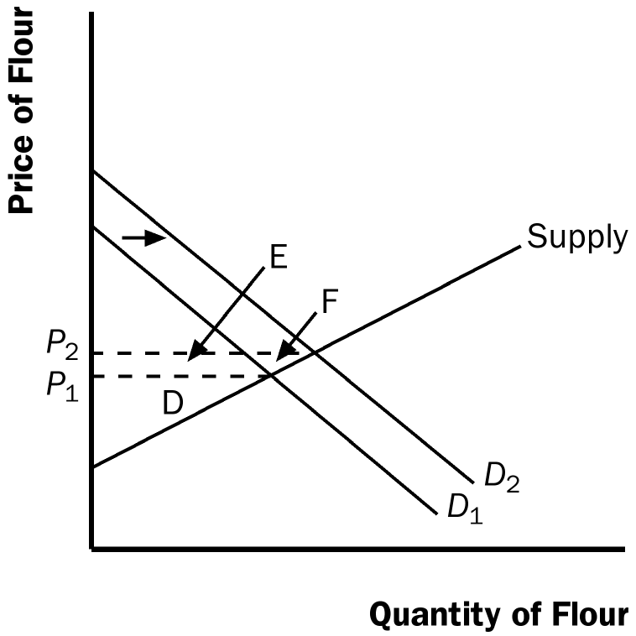

Figure 8

4. a. Bert’s demand schedule is:

Price | Quantity Demanded
More than $7 | 0
$5 to $7 | 1
$3 to $5 | 2
$1 to $3 | 3
$1 or less | 4

Bert’s demand curve is shown in Figure 9.

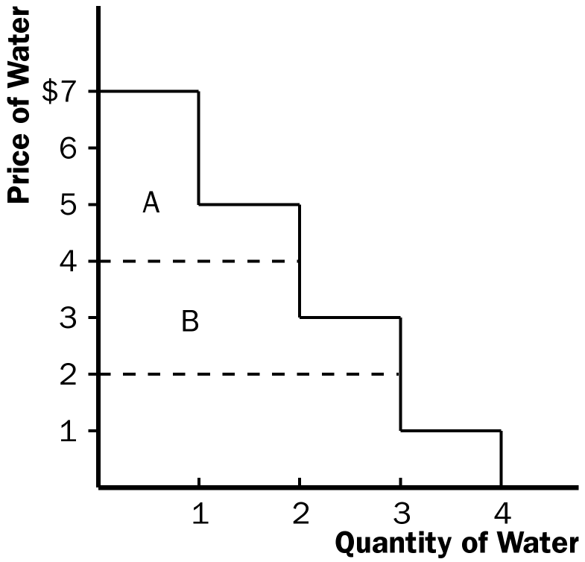

Figure 9

b. When the price of each bottle of water is $4, Bert buys two bottles of water. His consumer surplus is shown as area A in the figure. He values his first bottle of water at $7, but pays only $4 for it, so has consumer surplus of $3. He values his second bottle of water at $5, but pays only $4 for it, so has consumer surplus of $1. Thus Bert’s total consumer surplus is $3 + $1 = $4, which is the area of A in the figure.

c. When the price of each bottle of water falls from $4 to $2, Bert buys three bottles of water, an increase of one. His consumer surplus consists of both areas A and B in the figure, an increase in the amount of area B. He gets consumer surplus of $5 from the first bottle ($7 value minus $2 price), $3 from the second bottle ($5 value minus $2 price), and $1 from the third bottle ($3 value minus $2 price), for a total consumer surplus of $9. Thus consumer surplus rises by $5 (which is the size of area B) when the price of each bottle of water falls from $4 to $2.

5. a. Ernie’s supply schedule for water is:

Price | Quantity Supplied
More than $7 | 4
$5 to $7 | 3
$3 to $5 | 2
$1 to $3 | 1
Less than $1 | 0

Ernie’s supply curve is shown in Figure 10.

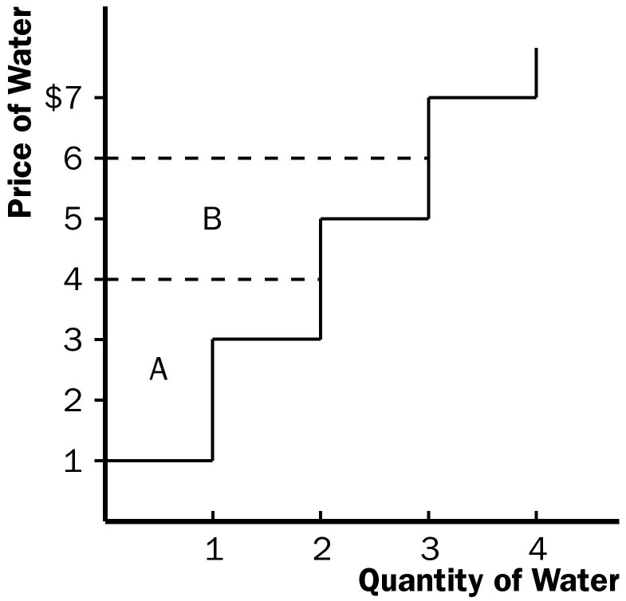

Figure 10

b. When the price of each bottle of water is $4, Ernie sells two bottles of water. His producer surplus is shown as area A in the figure. He receives $4 for his first bottle of water, but it costs only $1 to produce, so Ernie has producer surplus of $3. He also receives $4 for his second bottle of water, which costs $3 to produce, so he has producer surplus of $1. Thus Ernie’s total producer surplus is $3 + $1 = $4, which is the area of A in the figure.

c. When the price of each bottle of water rises from $4 to $6, Ernie sells three bottles of water, an increase of one. His producer surplus consists of both areas A and B in the figure, an increase by the amount of area B. He gets producer surplus of $5 from the first bottle ($6 price minus $1 cost), $3 from the second bottle ($6 price minus $3 cost), and $1 from the third bottle ($6 price minus $5 price), for a total producer surplus of $9. Thus producer surplus rises by $5 (which is the size of area B) when the price of each bottle of water rises from $4 to $6.

6. a. From Ernie’s supply schedule and Bert’s demand schedule, the quantity demanded and supplied are:

Price | Quantity Supplied | Quantity Demanded
$2 | 1 | 3
$4 | 2 | 2
$6 | 3 | 1

Only a price of $4 brings supply and demand into equilibrium, with an equilibrium quantity of two.

b. At a price of $4, consumer surplus is $4 and producer surplus is $4, as shown in Problems 3 and 4 above. Total surplus is $4 + $4 = $8.

c. If Ernie produced one less bottle, his producer surplus would decline to $3, as shown in Problem 4 above. If Bert consumed one less bottle, his consumer surplus would decline to $3, as shown in Problem 3 above. So total surplus would decline to $3 + $3 = $6.

d. If Ernie produced one additional bottle of water, his cost would be $5, but the price is only $4, so his producer surplus would decline by $1. If Bert consumed one additional bottle of water, his value would be $3, but the price is $4, so his consumer surplus would decline by $1. So total surplus declines by $1 + $1 = $2.

7. a. The effect of falling production costs in the market for flat-screen TVs results in a shift to the right in the supply curve, as shown in Figure 11. As a result, the equilibrium price of flat-screen TVs declines and the equilibrium quantity increases.
Price of flat-screen TVs
S₁
S₂

A

P₁
D
B
C
P₂
E
F
G

Demand

Quantity of flat-screen TVs
Q₁
Q₂

Figure 11

b. The decline in the price of flat-screen TVs increases consumer surplus from area A to A + B + C + D, an increase in the amount B + C + D. Prior to the shift in supply, producer surplus was areas B + E (the area above the supply curve and below the price). After the shift in supply, producer surplus is areas E + F + G. So producer surplus changes by the amount F + G – B, which may be positive or negative. The increase in quantity increases producer surplus, while the decline in the price reduces producer surplus. Because consumer surplus rises by B + C + D and producer surplus rises by F + G – B, total surplus rises by C + D + F + G.

c. If the supply of flat-screen TVs is very elastic, then the shift of the supply curve benefits consumers most. To take the most dramatic case, suppose the supply curve were horizontal, as shown in Figure 12. Then there is no producer surplus at all. Consumers capture all the benefits of falling production costs, with consumer surplus rising from area A to area A + B.

Price of flat-screen TVs

A
S₁
B
S₂

Demand

Quantity of flat-screen TVs

Figure 12

8. Figure 13 shows supply and demand curves for haircuts. Supply equals demand at a quantity of three haircuts and a price between $4 and $5. Firms A, C, and D should cut the hair of Claire, Gloria, and Phil. Jay’s willingness to pay is too low and firm B’s costs are too high, so they do not participate. The maximum total surplus is the area between the demand and supply curves, which totals $11 ($8 value minus $2 cost for the first haircut, plus $7 value minus $3 cost for the second, plus $5 value minus $4 cost for the third).

8
Claire
7
Gloria

6
B
5
Phil
4
Price of Haircuts
C
3
2
Jay
A
D
1

1
2
3
4
Quantity of Haircuts

Figure 13

9. a. The effect of falling production costs in the market for computers resulted in a shift to the right in the supply curve, as shown in Figure 14. As a result, the equilibrium price of computers declined and the equilibrium quantity increased. The decline in the price of computers increased consumer surplus from area A to A + B + C + D, an increase in the amount B + C + D.

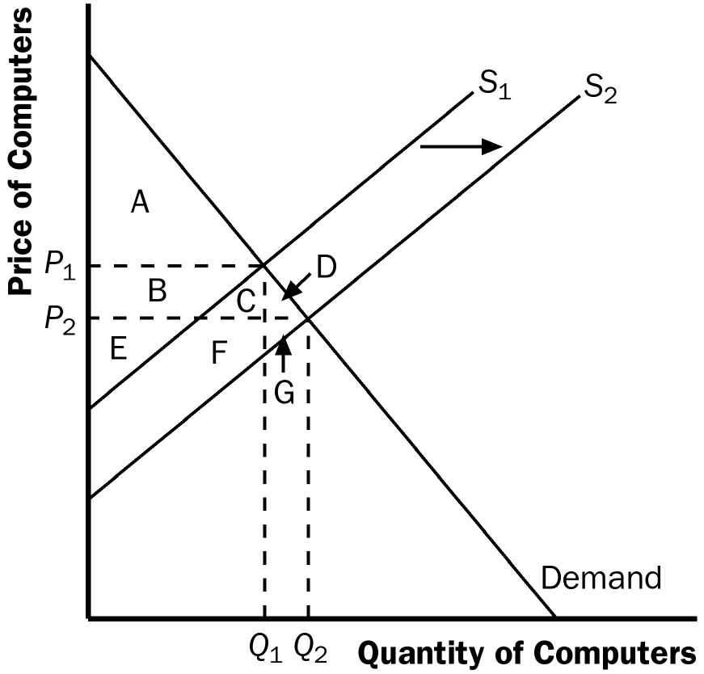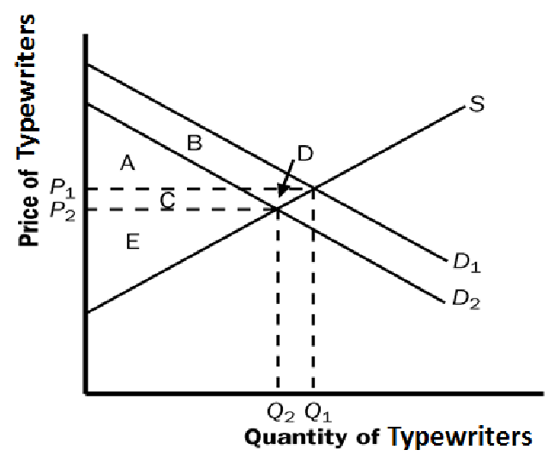

Figure 14 Figure 15

Prior to the shift in supply, producer surplus was areas B + E (the area above the supply curve and below the price). After the shift in supply, producer surplus is areas E + F + G. So producer surplus changes by the amount F + G – B, which may be positive or negative. The increase in quantity increases producer surplus, while the decline in the price reduces producer surplus. Because consumer surplus rises by B + C + D and producer surplus rises by F + G – B, total surplus rises by C + D + F + G.

b. Typewriters and computers are substitutes. The decline in the price of computers means that people substituted computers for typewriters, shifting the demand for typewriters to the left, as shown in Figure 15. The result is a decline in both the equilibrium price and equilibrium quantity of typewriters. Consumer surplus in the typewriter market changes from area A + B to A + C, a net change of C – B. Producer surplus changes from area C + D + E to area E, a net loss of C + D. Typewriter producers are sad about technological advances in computers because their producer surplus declines.

c. Software and computers are complements. When the price of computers decreases, the demand for software increases. The demand for software shifts to the right, as shown in Figure 16. The result is an increase in both the price and quantity of software. Consumer surplus in the software market changes from B + C to A + B, a net change of A – C. Producer surplus changes from E to C + D + E, an increase of C + D, so software producers should be happy about the technological progress in computers.

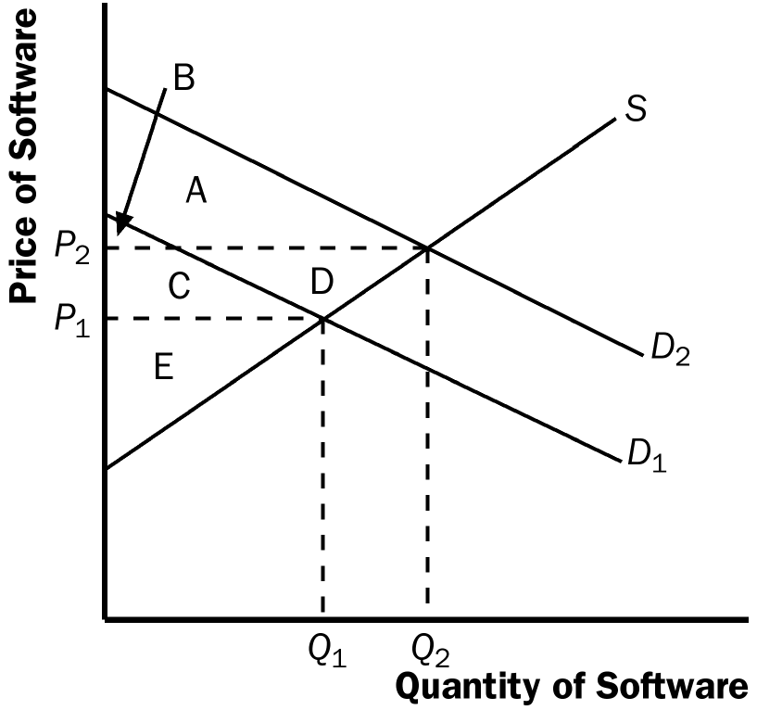

Figure 16

d. Yes, this analysis helps explain why Bill Gates is one the world’s richest people. His company produces a lot of software and the producer surplus in the software market increased with the technological advance in computers.

10. a. With Provider A, the cost of an extra minute is $0. With Provider B, the cost of an extra minute is $1.

b. With Provider A, my friend will purchase 150 minutes [= 150 – (50)(0)]. With Provider B, my friend would purchase 100 minutes [= 150 – (50)(1)].

c. With Provider A, she would pay $120. With Provider B, he would pay $100.

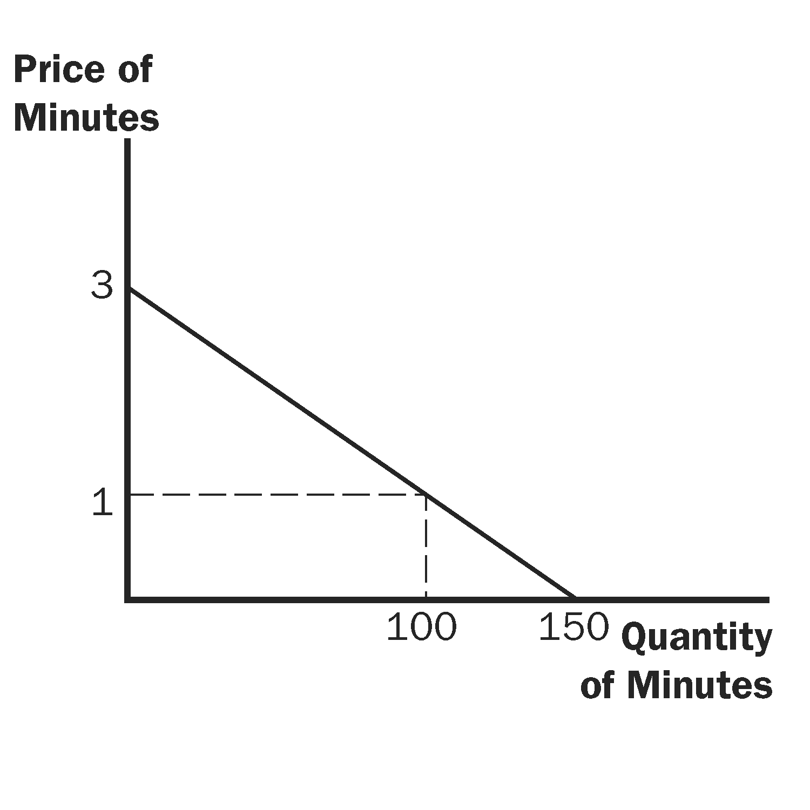

Figure 17

d. Figure 17 shows the friend’s demand. With Provider A, she buys 150 minutes and her consumer surplus is equal to (1/2)(3)(150) – 120 = 105. With Provider B, her consumer surplus is equal to (1/2)(2)(100) = 100.

e. I would recommend Provider A because she receives greater consumer surplus when buying from that provider.

11. a. Figure 18 illustrates the demand for medical care. If each procedure has a price of $100, quantity demanded will be Q₁ procedures.

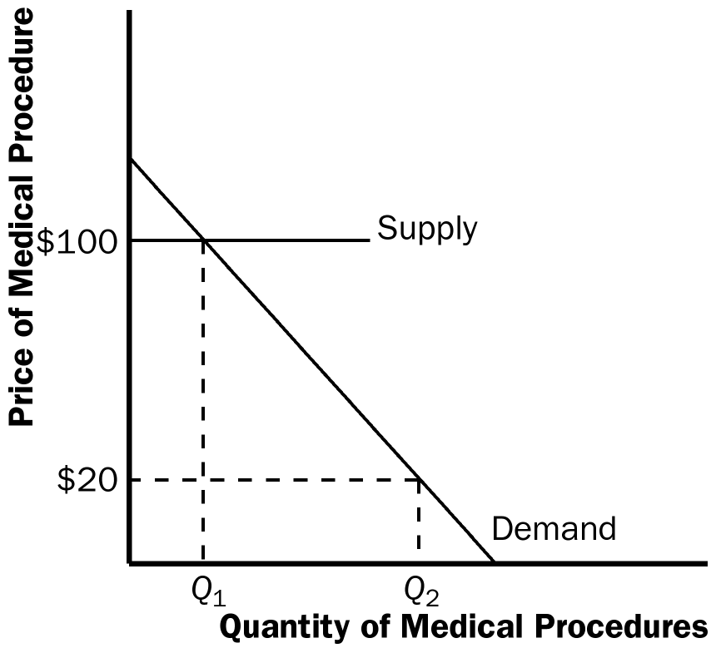

Figure 18

b. If consumers pay only $20 per procedure, the quantity demanded will be Q₂ procedures. Because the cost to society is $100, the number of procedures performed is too large to maximize total surplus. The quantity that maximizes total surplus is Q₁ procedures, which is less than Q₂.

c. The use of medical care is excessive in the sense that consumers get procedures whose value is less than the cost of producing them. As a result, the economy’s total surplus is reduced.

d. To prevent this excessive use, the consumer must bear the marginal cost of the procedure. But this would require eliminating insurance. Another possibility would be that the insurance company, which pays most of the marginal cost of the procedure ($80, in this case) could decide whether the procedure should be performed. But the insurance company does not get the benefits of the procedure, so its decisions may not reflect the value to the consumer.

